ACCOMPLISHMENT REPORT
IT 307 & 307L – Event-Driven Programming
Month: December – Year: 2025
School Year: 2025 – 2026 1st Semester

DATE | ACCOMPLISHMENT | REMARKS  (Progress and deviations from the plan) *
December 1 – 5, 2025 | Lecture Accomplishments:  - Completed remaining coverage for Module 3 and consolidated key Event-Driven Programming concepts in PHP and JavaScript (multi-page applications, file handling, and testing & debugging).  - Discuss how File handling works.  - Discussed secure and stable patterns for state management (sessions/cookies) and user feedback for asynchronous UI behaviors.  - Reviewed testing approach using test cases (inputs, expected outputs, actual results) and defect logging for multi-page workflows.  Laboratory Accomplishments:  - Directed students to finalize the integrated Module 3 mini-project (multi-page navigation + at least one file operation) for functional completeness and consistency.  - Required implementation upgrades based on November findings: improved input validation, clearer event-driven UI feedback (loading states), and consistent error messages/logging.  - Conducted hands-on debugging and QA (routing, file handling edge cases, session state issues).  - Collected final outputs with supporting evidence (screenshots, short test-case sheet, and brief changelog of fixes). | Accomplished  (Carryover items from November were completed: polishing of asynchronous UI behaviors, and testing/debugging artifacts. Integrated mini-projects were finalized and prepared for final assessment.)
December 8 – 12, 2025 (Examination Week) | Lecture Accomplishments:  - Prepared and administered the Final Examination (written) aligned to the syllabus scope (async event handling, multi-page web design, testing and debugging).  - Implemented exam controls: clear instructions, timeboxing, integrity reminders, and systematic checking and recording of results.  Laboratory Accomplishments:  - Conducted the Final Practical Assessment / Project Evaluation requiring an event-driven application demonstrating asynchronous interactions with proper validation and error handling.  - Checked outputs using rubric-based criteria (functionality, event handling correctness, error handling/validation, documentation, and overall quality).  - Recorded practical exam scores and documented recurring issues for feedback and continuous improvement. | Accomplished  (Final written and practical assessments were completed; graded artifacts and score records were prepared for consolidation.)
December 15 – 19, 2025 (Finalization of Sem 1) | Lecture Accomplishments:  - Completed checking and consolidation of lecture requirements and final examination results.  - Computed final lecture grades and validated class record entries for completeness and accuracy.  - Conducted consultation/feedback and resolved student clarifications on scoring and grading basis.  Laboratory Accomplishments:  - Completed checking of laboratory outputs (finalized integrated mini-project and practical exam artifacts).  - Consolidated final laboratory grades and verified minimum quality controls (correct event handling, validation, error handling, and documentation).  - Organized and archived objective evidence for semester closure (rubrics, sample outputs, screenshots, test-case sheets, and score summaries). | Accomplished  (Semester 1 class records were finalized; evidence was organized for audit traceability and program reporting.)

*Provide relevant documentation such as pictures, summary reports, etc.

Prepared by: Approved:

JUNNIE RYH M. SUMACOT SHERWIN G. CADAY, PhD.
Instructor Program Chair

PROOF/EVIDENCE OF REPORTED ACCOMPLISHMENTS
IT 307 & 307L – Event-Driven Programming
Month: December – Year: 2025
School Year: 2025 – 2026 1st Semester

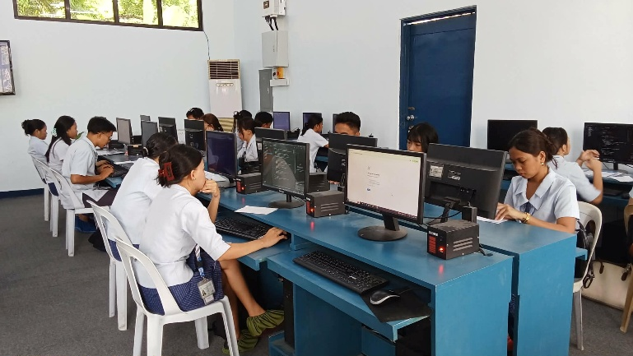
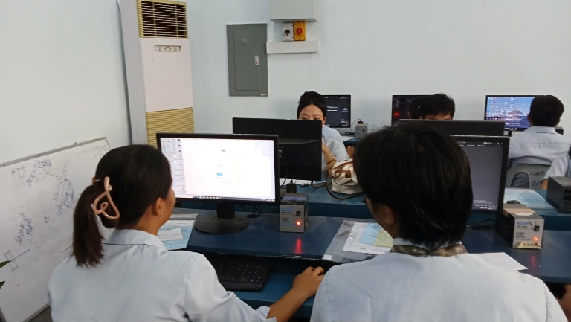

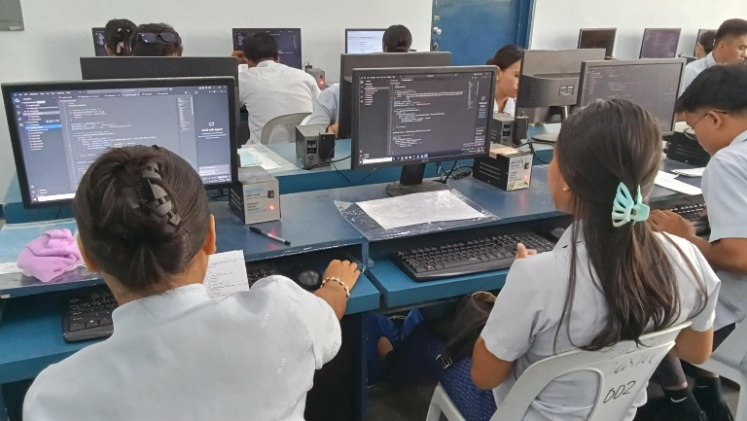
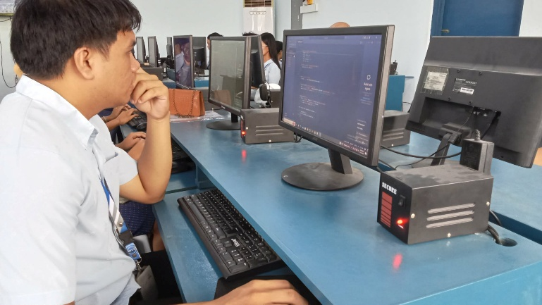

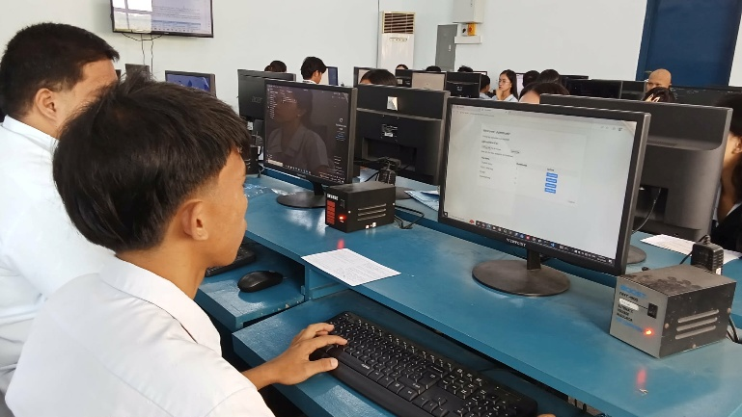
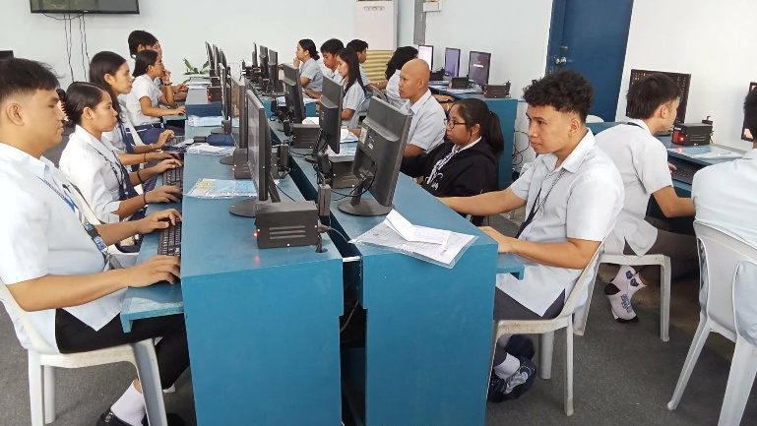

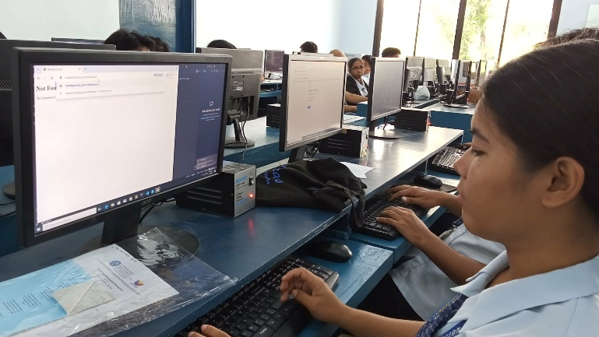
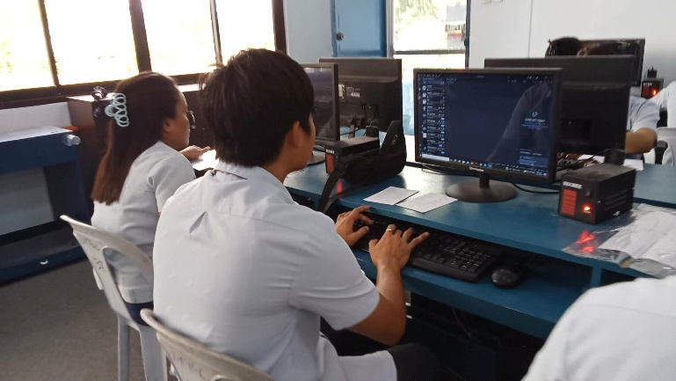

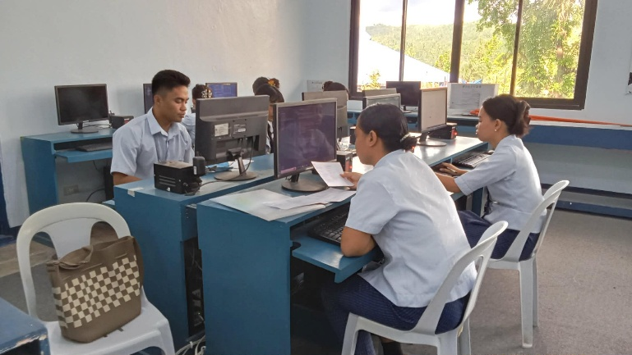
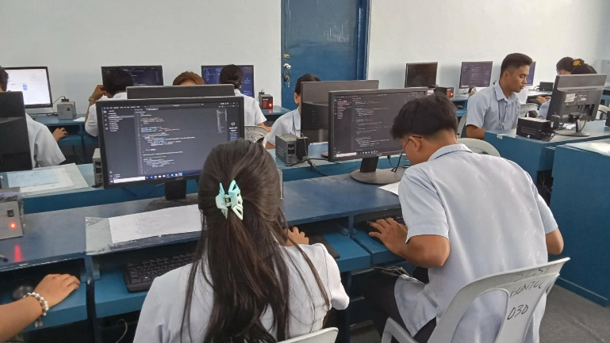
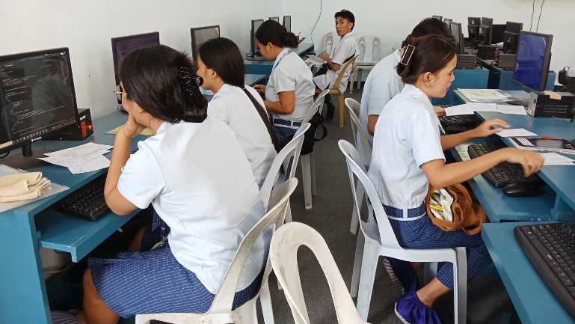
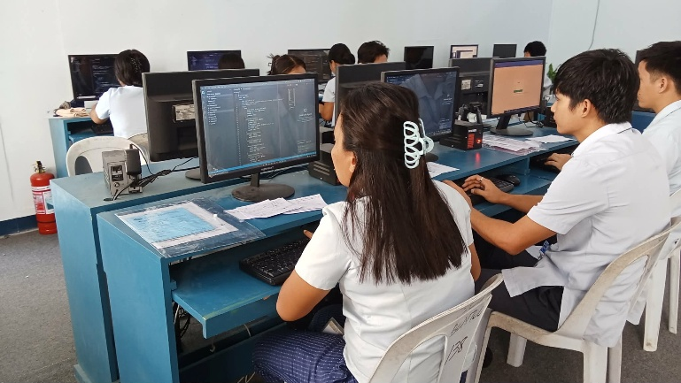

Prepared by: Approved:

JUNNIE RYH M. SUMACOT SHERWIN G. CADAY, PhD.
Instructor Program Chair

